**Chapter 6 exercise – installing web server (IIS) and PDS roles**

In this chapter exercise, you will learn how to do the following:

How to install a web server (IIS) role

How to install a PDS role

## Installing the web server (IIS) role

To install the web server (IIS) role in Windows Server 2019, complete the following steps:

1. Click the **Start** button and then, in the **Start** menu, click on **Server Manager**.
2. In the Server Manager window, click on the **Add roles and features** hyperlink.
3. Shortly, the **Add Roles and Features Wizard** will open, as shown in *Figure 6.31*:

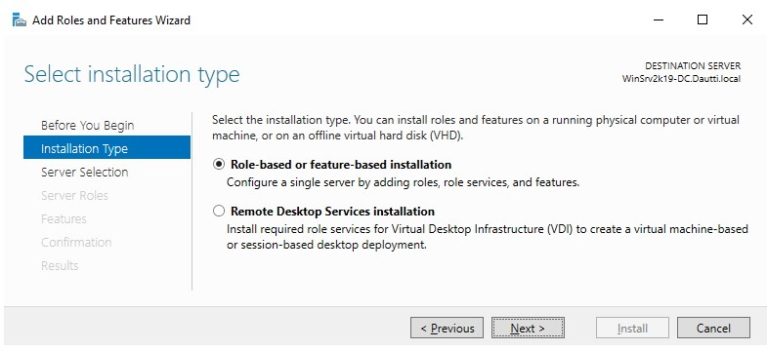

Figure 6.31:

Add Roles and Features Wizard

in Windows Server 2019

1. Accept the **Role-based or feature-based installation** option and click the **Next** button.
2. Ensure that the right server is highlighted from the server pool, then accept the **Select a server from the server pool** option and click **Next**.
3. From the list of the roles, select the **Web Server (IIS)** role.
4. Click the **Add Features** button when the **Add features that are required for Web Server (IIS)?** popup appears.
5. There is no feature required for adding the web server (IIS) role at this stage, so just click the **Next** button.
6. In the web server (IIS) definition and the things to note regarding web server (IIS) installation, click **Next** to proceed.
7. Either accept the web server (IIS) role services or customize them to your needs.
8. Confirm installation selections for the web server (IIS) role by clicking the **Install** button.
9. When installation progress reaches the end, click the **Close** button to close the *Add Roles and Features Wizard*.
10. A server restart is not required.

The web server (IIS) role will now get installed.

## Installing a PDS role

To install a PDS role in Windows Server 2019, complete the following steps:

1. Click the **Start** button and then, in the **Start** menu, click on **Server Manager**.
2. In the Server Manager window, click on the **Add roles and features** hyperlink.
3. Shortly, the **Add Roles and Features Wizard** will open.
4. Accept the **Role-based or feature-based installation** option and click the **Next** button.
5. Ensure that the right server is highlighted from the server pool, and then accept the **Select a server from the server pool** option and click **Next** (see *Figure 6.32*):

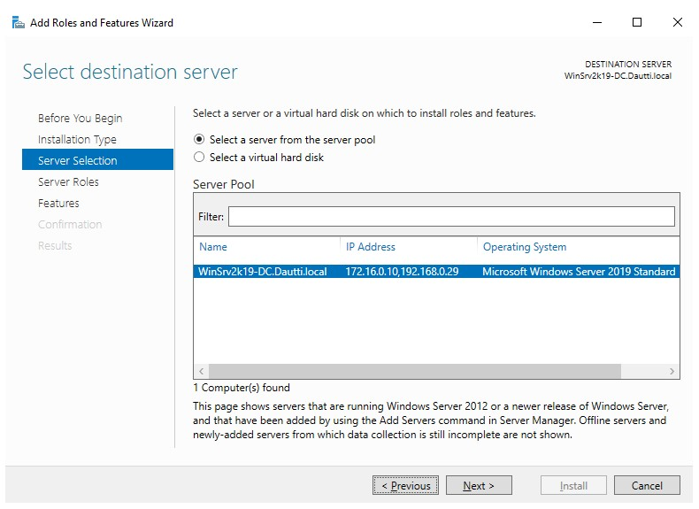

Figure 6.32: Accepting the defaults

1. From the list of the roles, select the **Print and Document Services** role.
2. Click the **Add Features** button when the **Add features that are required for Print and Document Services?** dialog pops up.
3. There is no feature required for adding PDS role at this stage, so just click the **Next** button.
4. In the PDS definition and the things to note regarding PDS installation, click **Next** to proceed.
5. Either accept the PDS role services or customize it to your needs.
6. Confirm the installation selections for the PDS role by clicking the **Install** button.
7. When installation progress reaches the end, click the **Close** button to close the **Add Roles and Features Wizard**.
8. A server restart is not required.

The PDS role will now get installed.